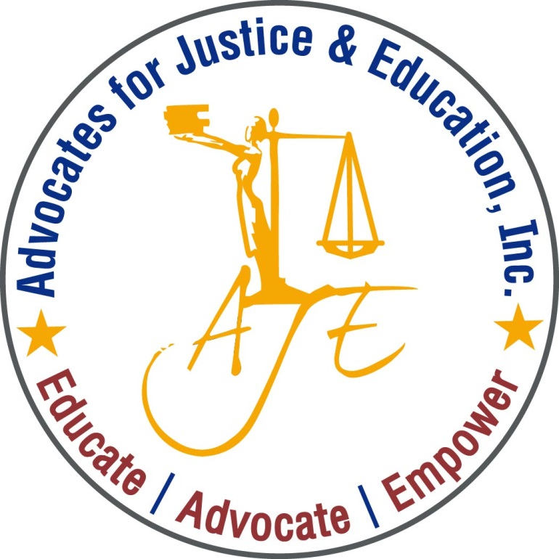
AJE’s

Advocates for Justice and Education

Invites you to our monthly
Public Policy Forum to Discuss

Medicare for all:
What is it really, and what does it mean for people with disabilities and their families?
(BRING YOUR OWN LUNCH)

1200 G Street NW Suite 725 (Metro Center)

November 19, 2018 | Noon – 1:30PM | 202-678-8060

Guest Speakers: Julian Blair & Terrence James from
Please RVSP to information@aje-dc.org

