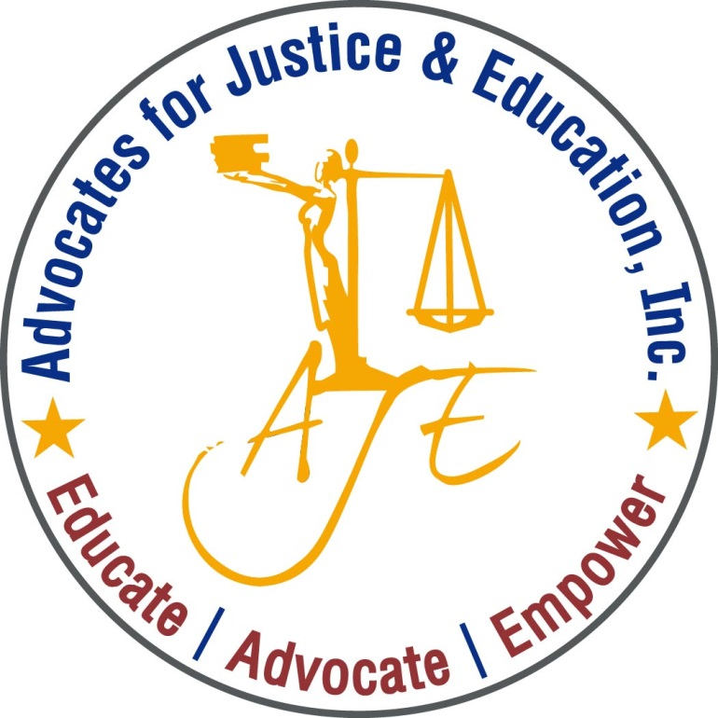
AJE’s

Advocates for Justice and Education

Invites you to our monthly
Public Policy Forum to Discuss

Restraint and Seclusion in DC:
What is the state of the law, and what does it mean for students and their families?

(BRING YOUR OWN LUNCH)

1200 G Street NW Suite 725 (Metro Center)

December 3rd, 2019 | Noon – 1:30PM | 202-678-8060

Guest Speaker:
Jessica V. Den Houter - Disability Rights DC
Protection & Advocacy Program

Please RVSP to information@aje-dc.org

