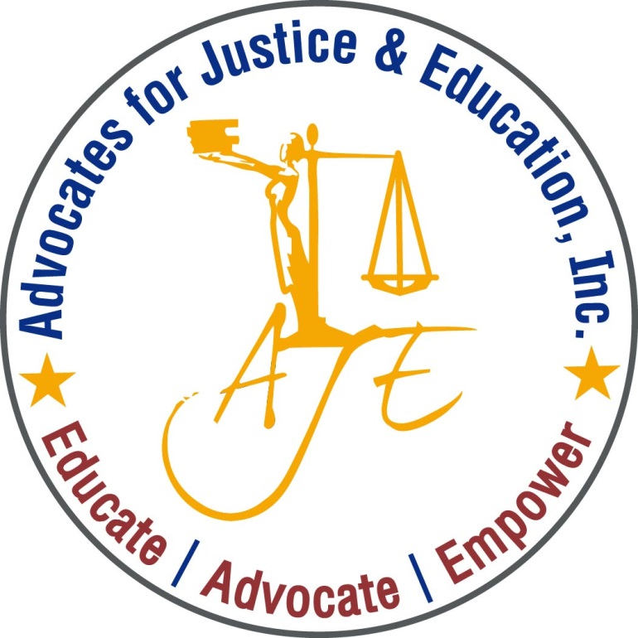
AJE’s

Advocates for Justice and Education

Invites you to our monthly
Public Policy Forum to Discuss

Best Practices for
Re-engaging Youth with School &
Other Educational Opportunities.

A practical conversation for professionals who support and serve out-of-school and/or chronically truant youth.

Remember to Bring Your Lunch!

1200 G Street NW Suite 725 (Metro Center)

February 25th, 2020 | Noon – 1:30PM | 202-678-8060

Please RVSP to information@aje-dc.org

