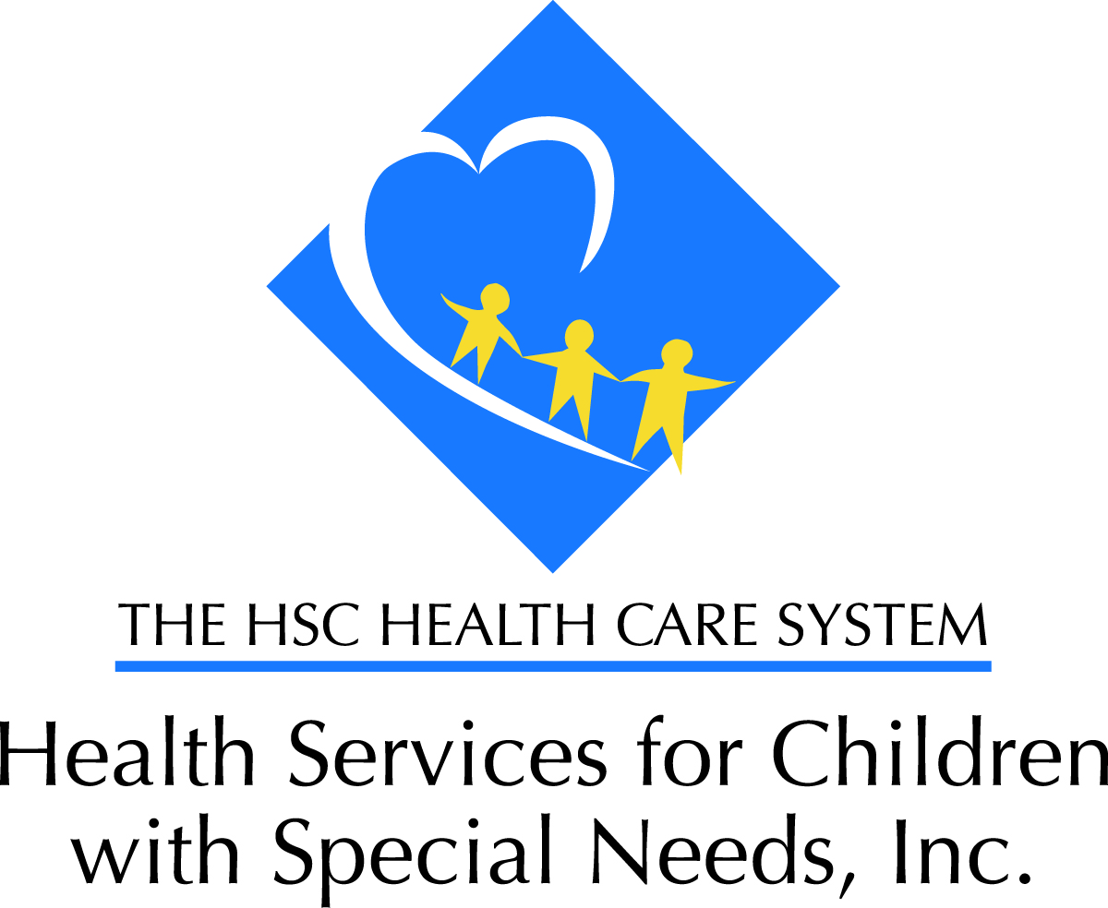

HSCSN Community Services Advisory Council (CSAC)
Thursday, June 17, 2021
6:00pm – 8:00pm

HSCSN, Community Services Advisory Council – Committee Nominations
Special presentations from DC Kincare Alliance.

Registration Link:
https://hschealth-org.zoom.us/meeting/register/tJIqfuqhqD0jGtZI6QvGNx-7inGHUaq7BD-Q
Meeting ID: 967 9396 6902
Agenda
5:45-6:00 | - Presenter Login | Presenters will login
6:00 - 6:05 | - Call to order  - Welcome & Introductions | Kyndra Jones  Manager, Marketing & Community Engagement  Outreach
6:05 - 6:10 | - Opening Remarks  - CSAC minutes – review of March meeting.  - OLD BUSINESS / NEW BUSINESS | Brian Gant.  LCPC, Program Director of the Autism Unit  & Associates for Renewal in Education  CSAC Co-Chair
6:10 – 6:15 | o COVID-19  o Bylaw Review  - Enrollee Engagement Survey: Event preferences | Kyndra Jones  Manager, Marketing & Community Engagement  Outreach
6:15 – 7:00 | Topic: It Takes a Village—When Relatives Help Care for Children with Special Needs. | Marla Spindel  Executive Director  DC Kincare Alliance
7:00- 7:10 | Open Floor for Q&A
7:10 – 7:30 | Officer Nominations | Enrollees and community participants
7:30 – 7:35 | HSCSN Leadership Remarks | Anna Dunn  President of HSCSN
7:35 - 7:40 | Upcoming Activities/Events & HSCSN Announcements | Lisa Proctor  VP of Marketing & Outreach
7:40 7:45 Open Floor for Q&A
7:45 – 7:55 | Announcements / Community Events | All Participating Organizations
7:55 - 8:00 | Enrollee Survey - ADJOURNMENT/SCHEDULING OF NEXT MTG. | September 16th , 2021

